Prepared by Dr. Mubenga EET3350 Chap9/10/11 Homework 25pts

Alexander J King

CHAP9/10: Timing is critical in embedded systems. We can use the Phase-Lock-Loop to change the system bus clock.

OBJECTIVES:
To become familiar with the PPL initialization
To verify the system bus clock
To set a specific delay
To use the logic analyzer to verify timing

TASK:
1) Give the definitions for

[ 1pt]Non-intrusiveness: Nonintrusiveness is the characteristic or quality of a debugger that allows the software/hardware system to operate normally as if the debugger did not exist.

[ 1pt] Stabilization: Stabilization is process of fixing the inputs so that the system can be run over and over again yielding repeatable outputs.

[ 1pt] Debugging instrument: A debugging instrument is hardware or software used for the purpose of debugging. In this class, we will study hardware-level probes like the logic analyzer, oscilloscope, and Joint Test Action Group (JTAG standardized as the IEEE 1149.1) interface; software-level tools like simulators, monitors, and profilers; and manual tools like inspection and print statements.

[ 1pt] White box testing: White-box testing allows you to control and observe the internal workings of a system. A common mistake made by new engineers is to just perform black box testing. Effective debugging uses both. One must always start with black-box testing by subjecting a hardware or software module to appropriate test-cases. Once we document the failed test-cases, we can use them to aid us in effectively performing the task of white-box testing.

[ 1pt] Black box testing: Black-box testing is simply observing the inputs and outputs without looking inside. Black-box testing has an important place in debugging a module for its functionality.

- The heartbeat code requires only 6 bus cycles to execute. If the heartbeat runs every 1ms and the bus clock is 60kHz, determine the measure of intrusiveness of the heartbeat code. Is this instrument minimally intrusive? [ 1pt]
6 cycles, 60000000 hz, runs every 1ms:
6/60000000. This is not less than 1/1000 so it is not minimally intrusive.

- Why does the microcontroller have a PLL? [ 1pt]

Without activating the phase-lock-loop (PLL), our TM4C123 LaunchPad will run at 16 MHz, meaning the SysTick counter decrements every 62.5 ns. If we activate the PLL to run the microcontroller at 80 MHz, then the SysTick counter decrements every 12.5 ns.
It speeds up the clock speed.

PROGRAMMING TASK:

If you don’t have it yet, you will need to install the EE319K_Install.exe installer which has the starter files for Lab1 through 10 and several other projects with example code for the TM4C123. The installer includes DLLs which will automatically attach into the Keil IDE. To Download the Install.exe

- Go to http://edx-org-utaustinx.s3.amazonaws.com/UT601x/EE319K_InstallSpring2015.exe
- Follow the instructions. The EE319KwareSpring2015 folder must be installed inside Keil in the My PC (Windows:C) .
Prepared by Dr. Mubenga EET3350 Chap9/10/11 Homework 25pts
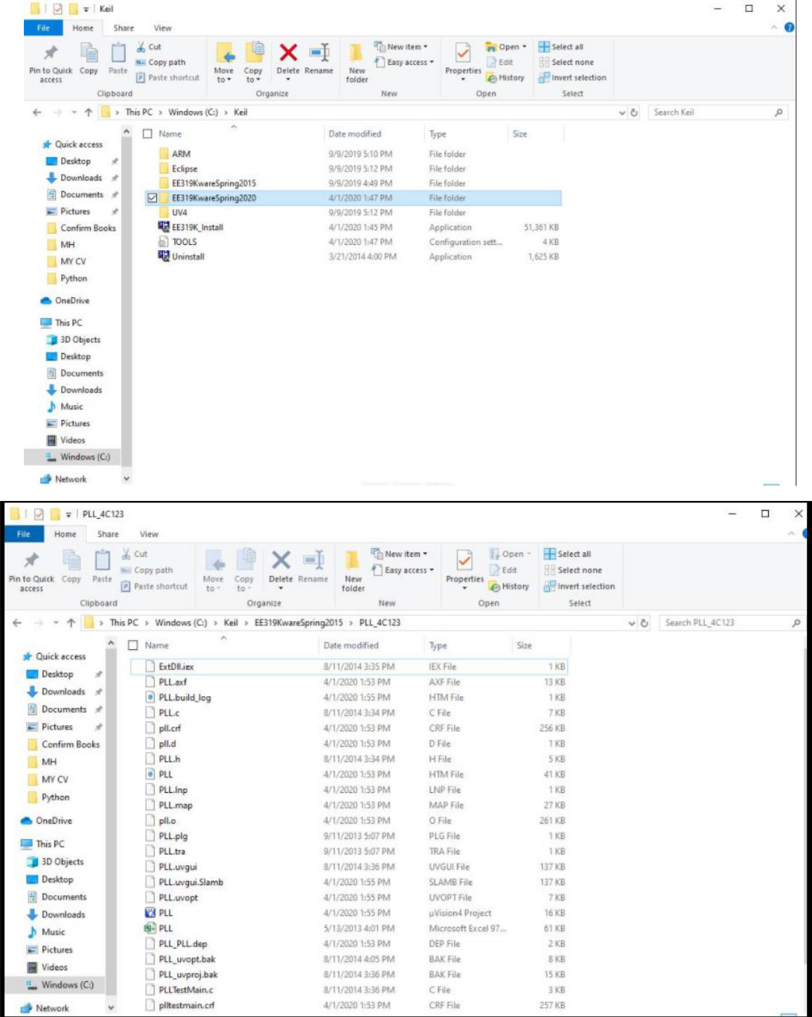

- Copy the PLL_4C123 project folder and rename it in this format
PLL_4C123_Name1_Name2 . You will be working within the folder you just renamed.

- Open KeiluVision, Project(Open ( PLL_4c123.uvproj . Observe the structure

of the following files: PLL.c, PLLTestMain.c, and PLL.h . Compare to the eBook chap10 initialization of PLL.

- To verify timing, run the program in simulator mode. Right click on PLL(Options for target. From the Debug Tab, select Simulator. Set the

Prepared by Dr. Mubenga EET3350 Chap9/10/11 Homework 25pts

Dialog DLL parameter to –pCM4 –dLaunchPadDLL and click OK.

- Run the PLL.c file in the simulation mode. Rebuild(Start debugging session(ok).
In the Debug Mode, click on Peripheral, select TeXas PORTF.

5. Open the Analysis window and set the logic analyzer (LA) to trace the LED on PF2. You need to create a new signal in the LA setup.
Syntax: ( PORTA & 0x000000##)>>#
Where A is the port, & is the mask, ## is the Hex value for first 8 bits, # is the GPIO pin number.

For PF2, binary is 00000100, which is 04 in hex. So we set (PORTF & 0x00000004)>>2 , specify the display type as Bit, and select the color. Click ok.
Add a trace for SW1 (PF4)
5.A.What is the LA setup for PF4? [ 1pt]
(PORTF & 0x00000010) >>2

- To display the Texas simulator, → Peripherals→ Texas portF
- Run the program. The LA will display the traces for the output LED (PF2) and SW1 (PF4)

- Use the cursor to measure time on the PF2 signal. Click on Update Screen

Stop, then click at the beginning of the quantity you desire to measure, and hover the cursor to the end of the signal. The measurement will be displayed in a window by the cursor.You can zoom in , zoom out or display all the signal from the zoom window.

- The delay function is located in PLLTestMain.

The syntax is Delay (Nbr of ticks), where Nbr of ticks= delay x freq. Using the LA and the simulator

9A. What is the Nbr of ticks , the number between () in the Delay function? [ 1pt]
13333333
9B. What is the bus frequency? [ 1pt]
80HZ
9C.Measure the time the LED is ON [ 1pt]
The comments suggests at 80 hz and a 13333333 delay that it should be half a second. Actually measuring this it is 0.67s
9D.Measure the time the LED is OFF [ 1pt]
Same 0.67s
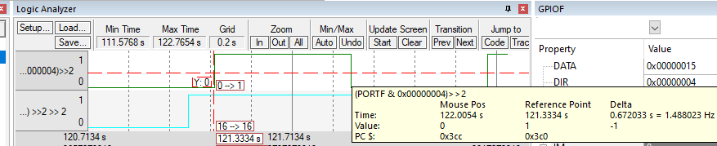
9E. What is the switching frequency? [ 1pt]
It switches 2 per sec so 2hz.

- Adjust the Delay function to have the LED on for exactly 0.5s, and OFF for exactly 0.5s at 80MHz.

10A. What is the Nbr of ticks, the number between () in the Delay function? [ 1pt]
10000000

10B. What is the bus frequency? [ 1pt]
It is running at 80mhz.
Screenshot from given PLL.H. This GIVEN comment seems to say IT IS 400MHz. My peers disagree and are saying it is just 80MHz. This is confusing.

Prepared by Dr. Mubenga EET3350 Chap9/10/11 Homework 25pts

10C.Measure the time the LED is ON [ 1pt]
0.5 sec
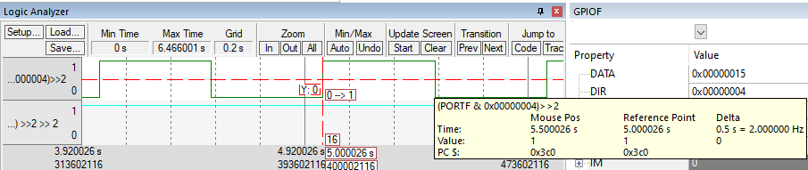
10D.Measure the time the LED is OFF [ 1pt]
0.5 sec
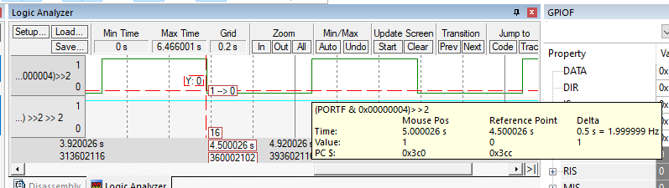

11. Changing the bus clock to a desired value (40MHz)

To change the system clock, adjust the SYSDIV2 located in the PLL.h file. The formula is Bus clock= 400MHz/ (SYSDIV2+1)
Use Table 10.1 provided in the code to select the correct divisor.
11A. To change the bus clock to run at 40MHz, what is the value of SYSDIV2? [ 1pt]
if 4+1 = 5 gave us 80 when bus freq is 400MHz (given line 27 of PLL.H) then it would follow to make it half of the previous answer we would double the dividend.
400MHz / 10 = 40 which would be SYSDIV2 = 9+1

Rebuild and run the program in the simulator.
Using the LA, measure
11B. the time the LED is ON and OFF [ 1pt]
On 1s off 1s
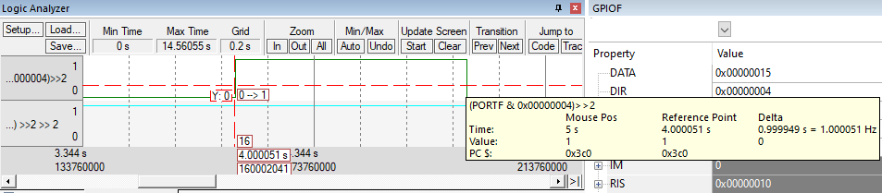

11.C: Include a screenshot showing the LA trace and the MHz on the simulator. [ 1pt]
Exactly the same LA section from above but with 40MHz showing below it this time.

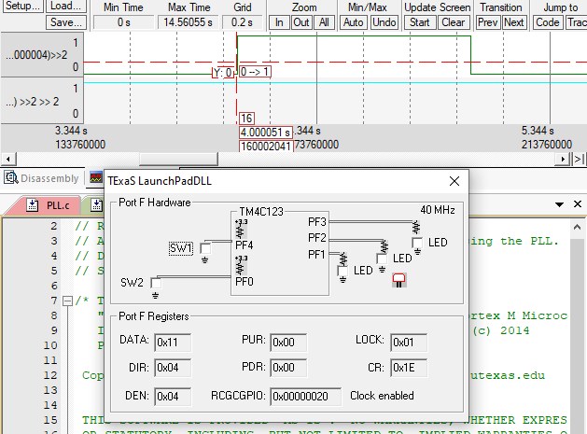

CHAP11: This is an introduction to serial interfacing, which means we send one bit at time. Serial communication is prevalent in both the computer industry in general and the embedded industry in specific. We will focus on UART, one of the first and simplest protocols that transmit one bit at a time.

OBJECTIVES:

- Why do we need I/O synchronization? [ 1pt]
To prevent lost data. If I send data every 0.5 sec and you only check for it every 1 sec half of the data will be lost.

Synchronized data is important when the integrity of the data is crucial to an application.

- What does UART stand for? [ 1pt]
Universal Asynchronous Receiver Transmitter

PROGRAMMING TASK
- Copy the UART_4C123 project folder and rename it in this format

UART_4C123_Name1_Name2 . You will be working within the folder you just renamed.

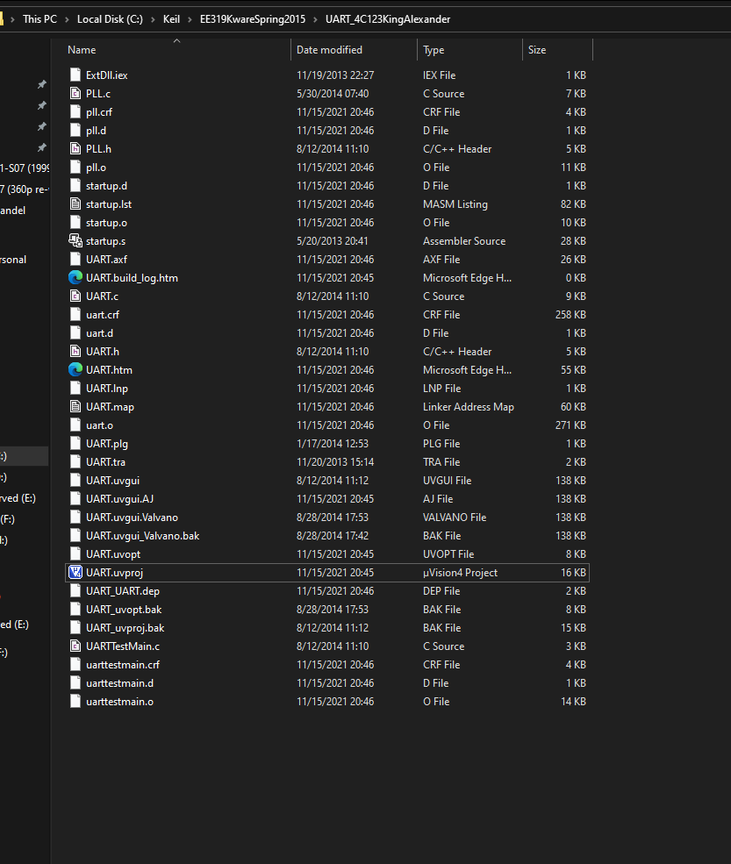

- Run the example for UART_4C123 in the simulator. Change the string to display “Your Name EET3350”. Record a screenshot of the simulated UART display with your name. [ 1pt]
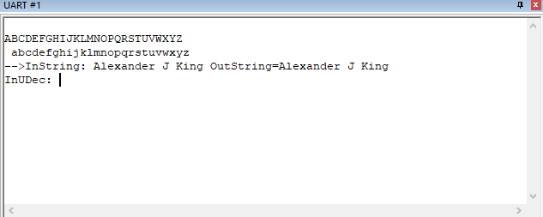

this is how it was shown in class just typing my name… previously I made it print out the characters of my name before ABCD…. And then the LAB PC crashed and my work disappeared…. But the professor gave what I provided as an in-class example of how to do this.

- In your own word, explain how UART1_IBRD_R and UART1_FBRD_R used to determine the baud rate in this example. Show the calculation. [ 1pt]
From my in class notes… in my own words:
FBRD is the “fractional board rate divisor” and IBRD is Interger board rate devisor.

I = int, variable “M”
F = fractional, variable “N”.

They are both registers to set the baud rate.

UART0_IBRD_R = 27; // IBRD = int(50,000,000 / (16 * 115,200)) = int(27.1267)
UART0_FBRD_R = 8; // FBRD = int(0.1267 * 64 + 0.5) = 8

r = R/n
ex 50 = 27/0.54
or 50 = 8 / 0.16

Prepared by Dr. Mubenga EET3350 Chap9/10/11 Homework 25pts

- From the example, show the GPIO initialization, and their corresponding Hex value [ 1pt]
As seen from code attached below.

PORT |  | Bit 7 | Bit 6 | Bit 5 | Bit 4 | Bit 3 | Bit 2 | Bit 1 | Bit 0 | Hex
 |  |  |  |  |  |  |  |  |  | Value
RCGC |  | 0 | 0 | 0 | 0 | 0 | 0 | 0 | 1 | 0x01
DIR |  | 0 | 0 | 0 | 0 | 0 | 0 | 0 | 0 | 0x00
PCTL |  | 0 | 0 | 0 | 0 | 0 | 0 | 1 | 1 | 0x03
AFSEL |  | 0 | 0 | 0 | 0 | 0 | 0 | 1 | 1 | 0x03
AMSEL |  | 0 | 0 | 0 | 0 | 0 | 0 | 1 | 1 | 0x03
DEN |  | 0 | 0 | 0 | 0 | 0 | 0 | 1 | 1 | 0x03
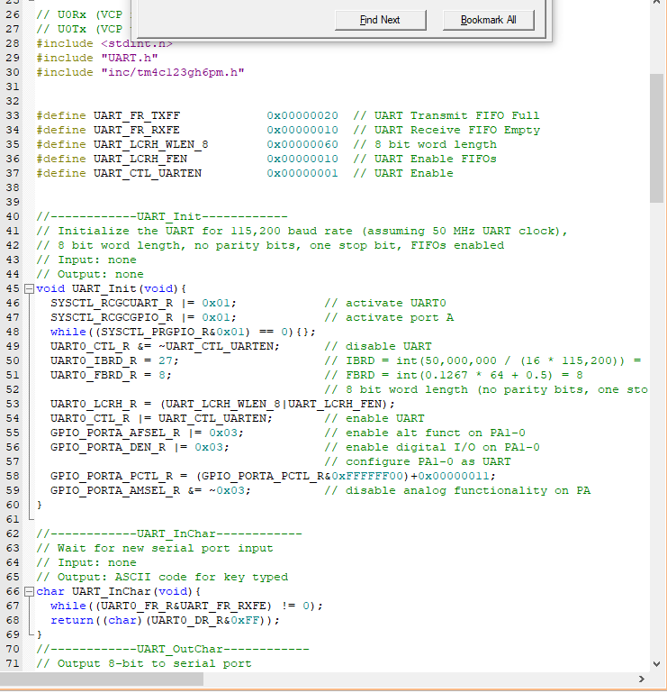
A

